JAT TASK-4(OUTPUT)

1. SUM OF (A+B) IS GREATER THAN (C+D)

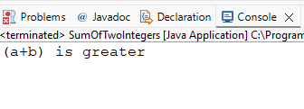

1. EVEN NUMBER OR NOT

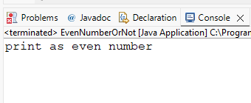

1. PRINT(A – Z)

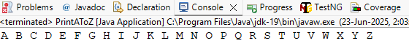

1. SWAP TWO NUMBERS

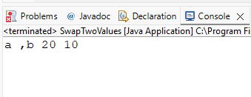

1. CHECK WHETHER PRIME OR NOT

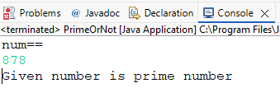

1. FACTORIAL OF GIVEN NUMBER

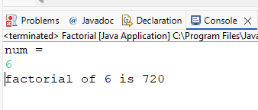

1. LENGTH OF STRING

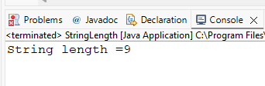

1. WELCOME TO GUVI

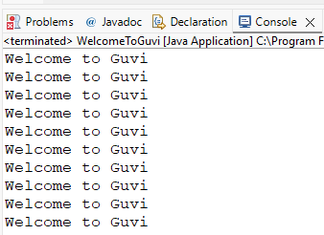

1. SENIOR CITIZEN(CHECK)

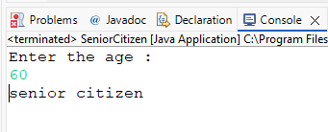

1. NUMBER OF DIGITS IN INTEGER

